Supplementary Information for

Cross-Body Site Microbial Interactions Influence the Human Plasma Metabolome

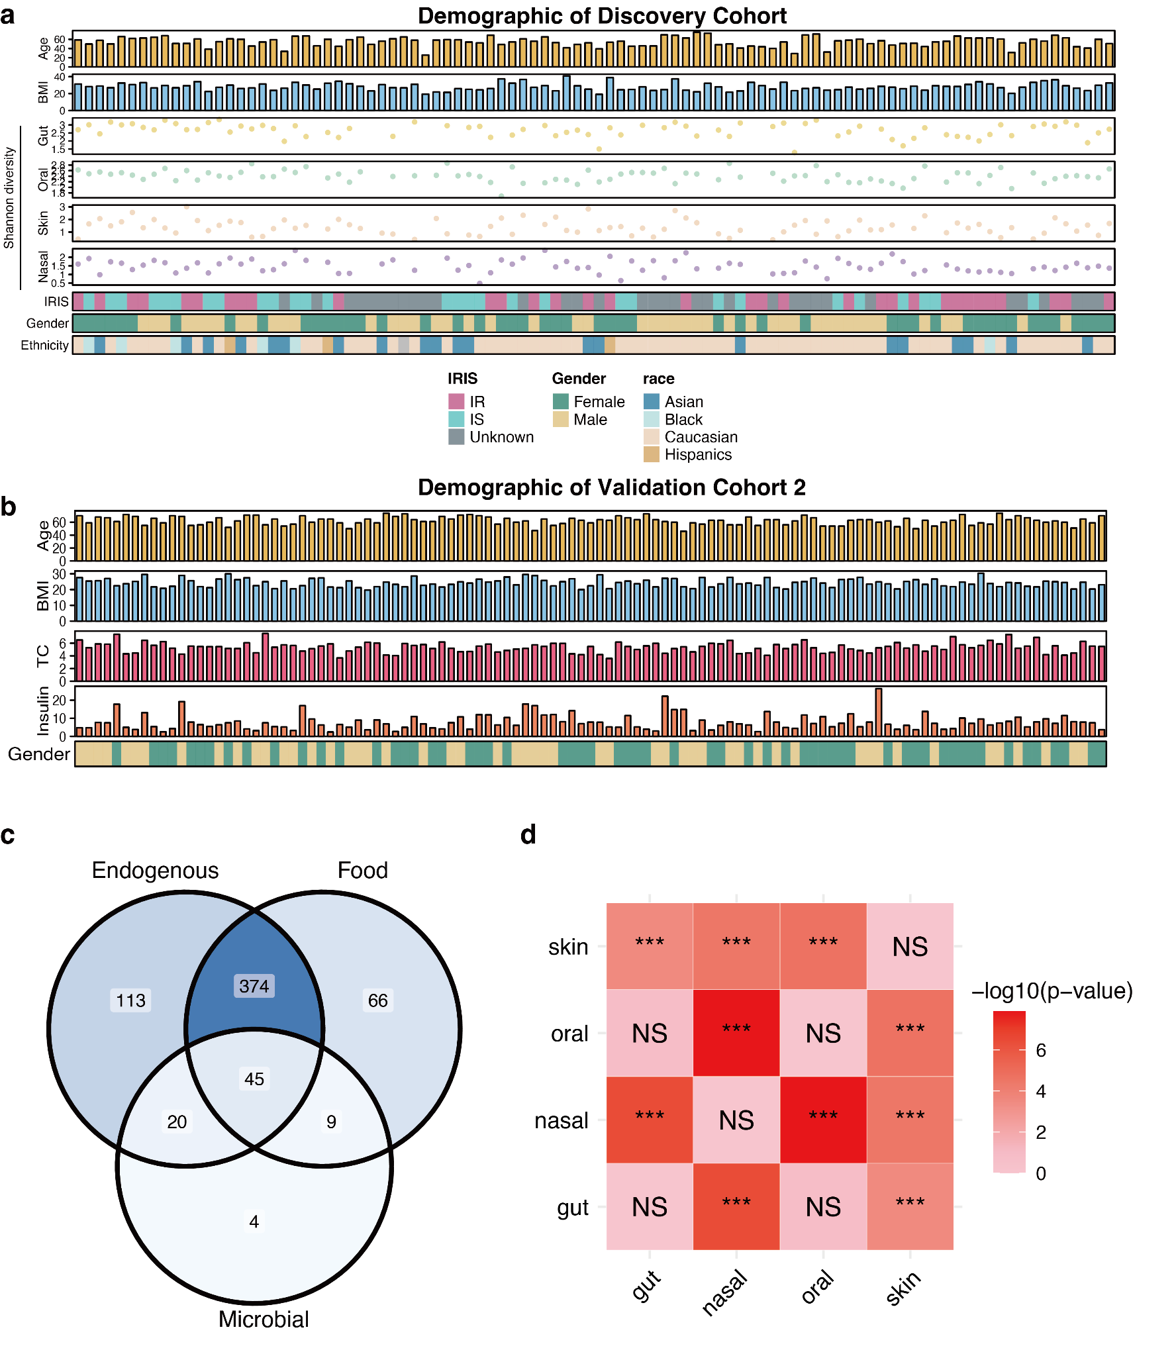
Extended Data Fig. 1 | a-b, The demographics of discovery and validation cohorts 2. Top: Discovery cohort, bottom: validation cohort 2. c, The Venn diagram showing the distribution of detected metabolites by origin based on HMDB annotation. d, Chi-squared test of metabolite class distribution across different body sites. The heatmap shows pairwise comparisons of metabolite type distributions associated with four body sites: gut, nasal, oral, and skin.

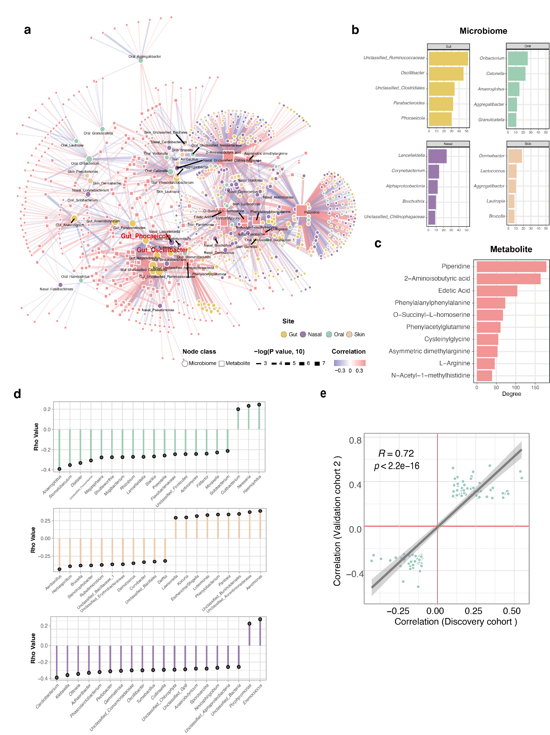s
Extended Data Fig. 2 | a, The correlation network of microbiota and metabolites. b, The top 5 genera with the highest degrees in the network of each body site. c, The top 10 metabolites with the highest degrees in the network. d, The lollipop plots showing the top 20 genera with the strongest correlation with metabolome PC1 in each body site. e, Spearman correlation of the top 100 most significant metabolites-bacteria association in the discovery and validation cohorts 2.
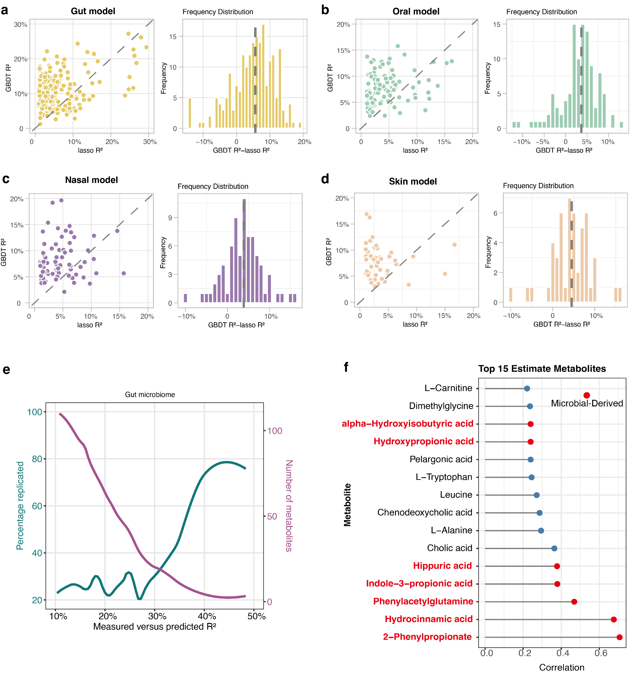
Extended Data Fig. 3 | a-d, Distribution of R² values ​​for GBDT and lasso models for four body sites. e, R² of predicted metabolites in the discovery cohort plotted against the rate of replicated associations in the validation cohort 2, computed as the fraction of significant replications out of all predictions with equal or higher predicted R² in our cohort, and the cumulative number of metabolites. f, The top 15 metabolites that could be successfully validated in the validation cohort 2.

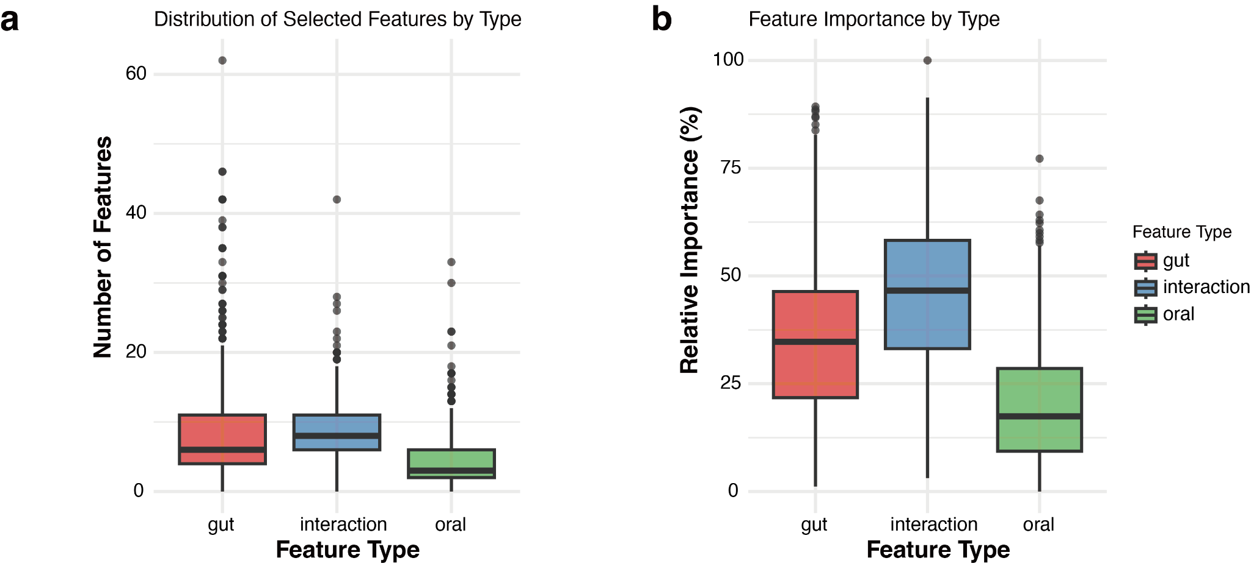
Extended Data Fig. 4 | a, The number of features from different categories to be included in the joint GBDT model (oral and gut microbiomes). b, The cumulative importance contribution percentage of features of different categories.

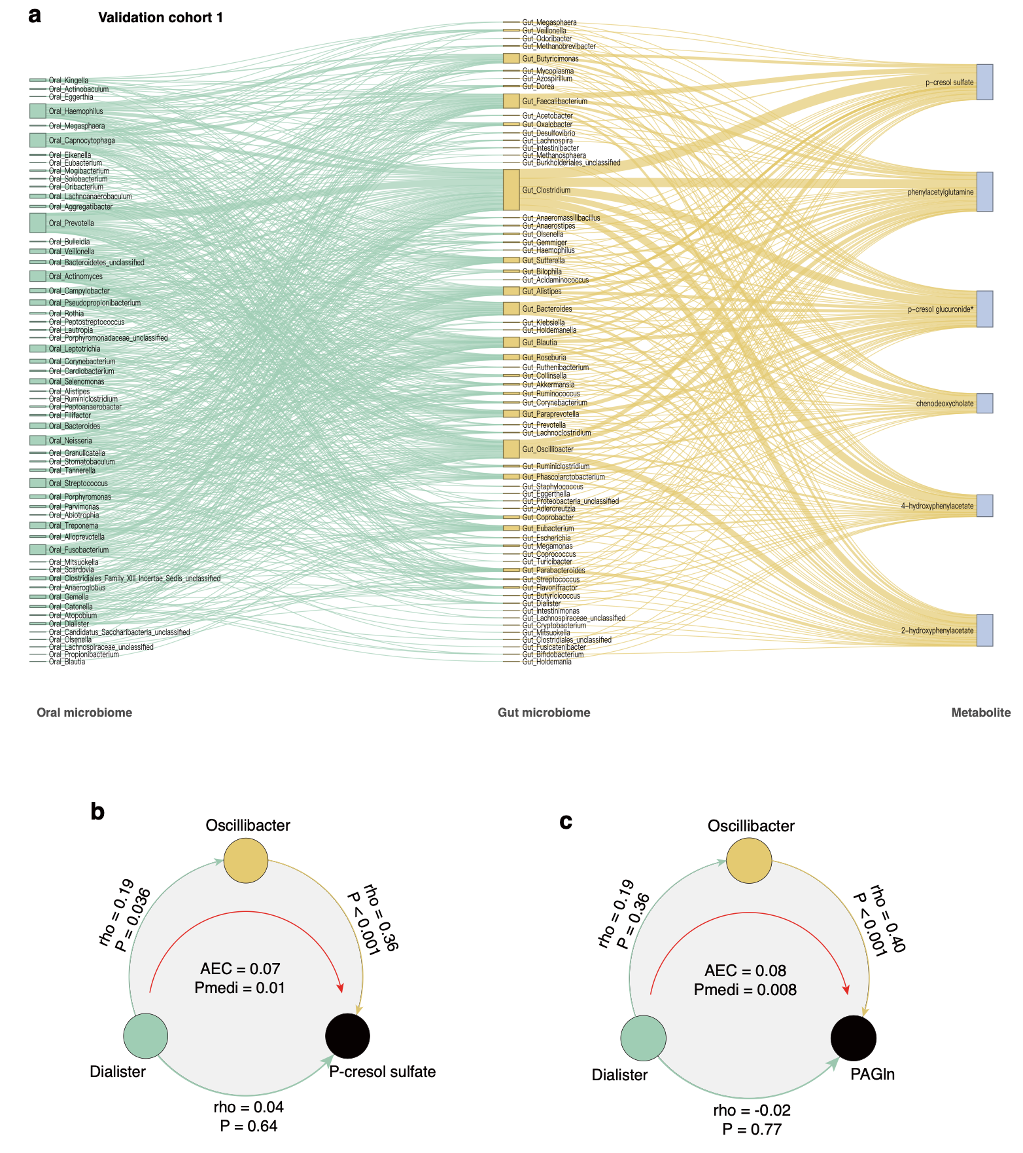
Extended Data Fig. 5 | a, Sankey diagram illustrating significant mediation effects identified in the validation cohort 1. Edges connect taxa from the oral microbiome (left) to gut microbial genera (middle) and ultimately to plasma metabolites (right). b-c, Circular mediation diagrams showing specific examples of oral-gut microbial cooperation in influencing plasma metabolites in the validation cohort 1.

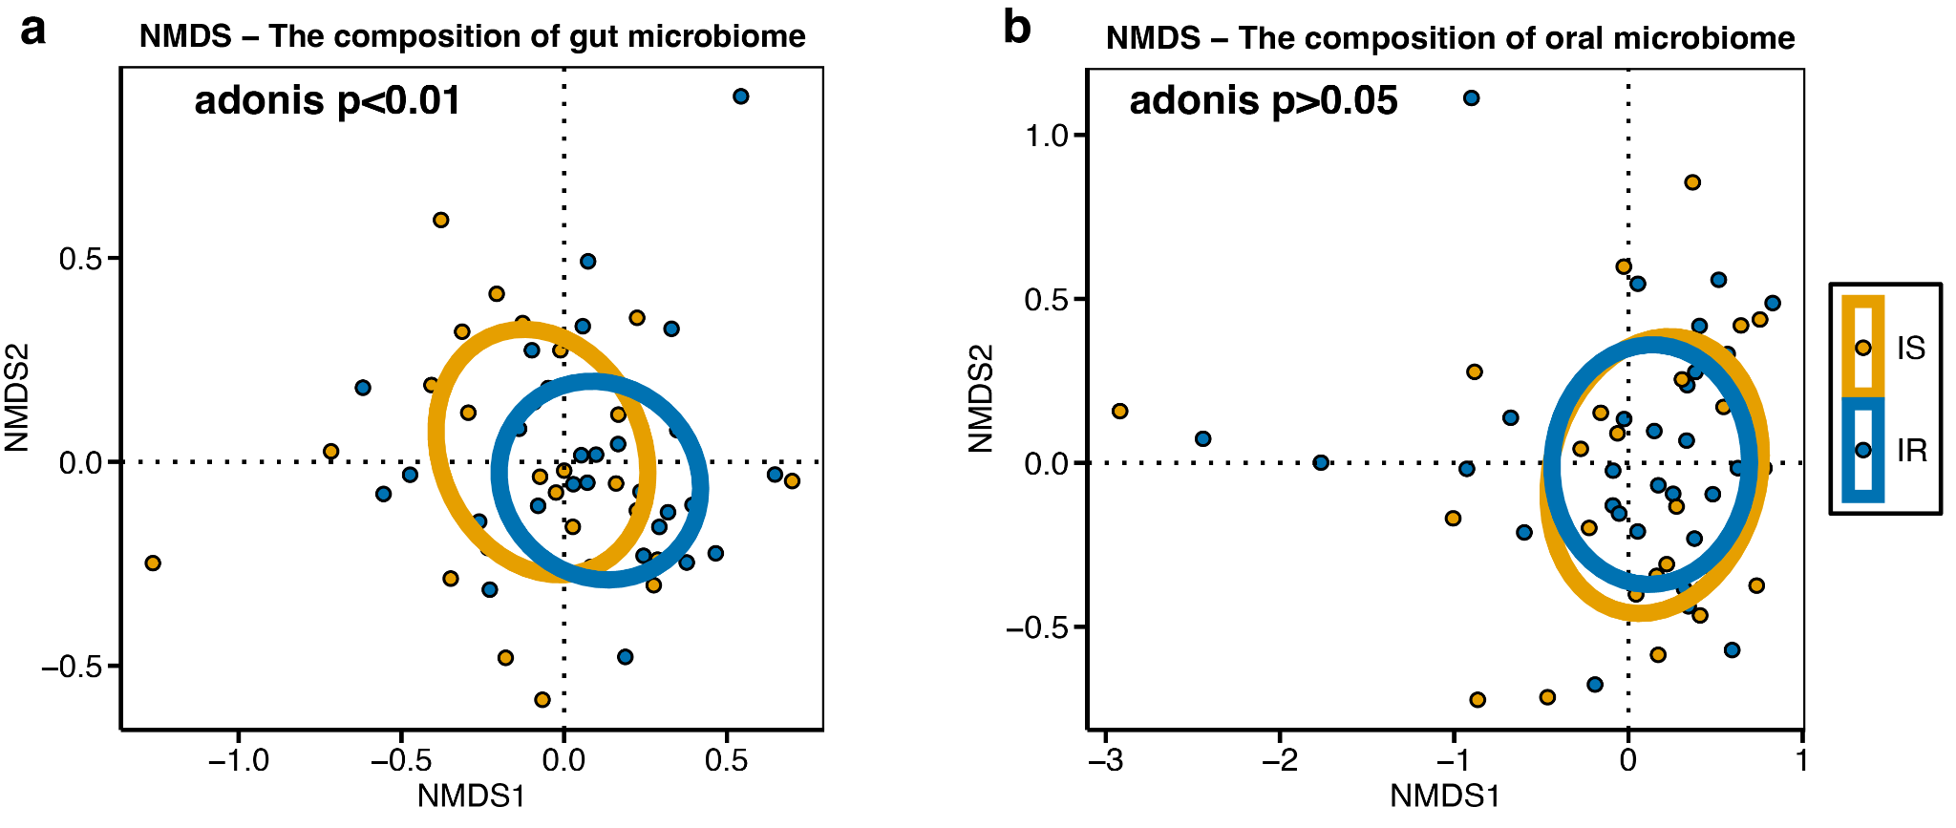
Extended Data Fig. 6 | a-b, NMDS ordination plot showing Bray-Curtis distances of gut and oral microbial communities (stress = 0.097/0.093). Points represent individual samples colored by insulin sensitivity status.

Supplementary Note

R version 4.4.1 (2024-06-14)
Platform: aarch64-apple-darwin20
Running under: macOS 15.5

attached base packages:
[1] stats4 stats graphics grDevices utils datasets methods base

other attached packages:
[1] MSnbase_2.30.1 ProtGenerics_1.36.0 S4Vectors_0.42.1 mzR_2.38.0 Rcpp_1.0.13-1 Biobase_2.64.0 BiocGenerics_0.50.0 ggplot2_3.5.1 massdataset_1.0.34
[10] dplyr_1.1.4 magrittr_2.0.3 masstools_1.0.13 metid_1.2.35 metpath_1.0.8

loaded via a namespace (and not attached):
[1] RColorBrewer_1.1-3 rstudioapi_0.17.1 jsonlite_1.8.9 shape_1.4.6.1 MultiAssayExperiment_1.30.3 rmarkdown_2.29
[7] farver_2.1.2 MALDIquant_1.22.3 GlobalOptions_0.1.2 zlibbioc_1.50.0 vctrs_0.6.5 memoise_2.0.1
[13] RCurl_1.98-1.16 progress_1.2.3 htmltools_0.5.8.1 S4Arrays_1.4.1 cellranger_1.1.0 SparseArray_1.4.8
[19] mzID_1.42.0 parallelly_1.39.0 htmlwidgets_1.6.4 plyr_1.8.9 plotly_4.10.4 impute_1.78.0
[25] cachem_1.1.0 igraph_2.1.1 lifecycle_1.0.4 iterators_1.0.14 pkgconfig_2.0.3 Matrix_1.7-1
[31] R6_2.5.1 fastmap_1.2.0 GenomeInfoDbData_1.2.12 MatrixGenerics_1.16.0 future_1.34.0 clue_0.3-65
[37] digest_0.6.37 pcaMethods_1.96.0 colorspace_2.1-1 furrr_0.3.1 GenomicRanges_1.56.2 fansi_1.0.6
[43] httr_1.4.7 polyclip_1.10-7 abind_1.4-8 compiler_4.4.1 remotes_2.5.0 withr_3.0.2
[49] doParallel_1.0.17 BiocParallel_1.38.0 viridis_0.6.5 ggforce_0.4.2 MASS_7.3-61 DelayedArray_0.30.1
[55] rjson_0.2.23 tools_4.4.1 PSMatch_1.8.0 zip_2.3.1 glue_1.8.0 QFeatures_1.14.2
[61] grid_4.4.1 cluster_2.1.6 reshape2_1.4.4 generics_0.1.3 gtable_0.3.6 tzdb_0.4.0
[67] preprocessCore_1.66.0 tidyr_1.3.1 data.table_1.16.2 hms_1.1.3 tidygraph_1.3.1 utf8_1.2.4
[73] XVector_0.44.0 ggrepel_0.9.6 foreach_1.5.2 pillar_1.9.0 stringr_1.5.1 limma_3.60.6
[79] circlize_0.4.16 tweenr_2.0.3 lattice_0.22-6 tidyselect_1.2.1 ComplexHeatmap_2.20.0 Biostrings_2.72.1
[85] pbapply_1.7-2 knitr_1.49 gridExtra_2.3 IRanges_2.38.1 SummarizedExperiment_1.34.0 xfun_0.49
[91] graphlayouts_1.2.0 statmod_1.5.0 matrixStats_1.4.1 stringi_1.8.4 UCSC.utils_1.0.0 yaml_2.3.10
[97] lazyeval_0.2.2 evaluate_1.0.1 codetools_0.2-20 ggraph_2.2.1 MsCoreUtils_1.16.1 tibble_3.2.1
[103] BiocManager_1.30.25 cli_3.6.3 affyio_1.74.0 munsell_0.5.1 readxl_1.4.3 GenomeInfoDb_1.40.1
[109] globals_0.16.3 png_0.1-8 XML_3.99-0.17 parallel_4.4.1 readr_2.1.5 prettyunits_1.2.0
[115] AnnotationFilter_1.28.0 bitops_1.0-9 listenv_0.9.1 viridisLite_0.4.2 scales_1.3.0 affy_1.82.0
[121] openxlsx_4.2.7.1 ncdf4_1.23 purrr_1.0.2 crayon_1.5.3 GetoptLong_1.0.5 rlang_1.1.4

